Step 1: Login to Microsoft Azure

Step 2: click on create resources->Virtual Network

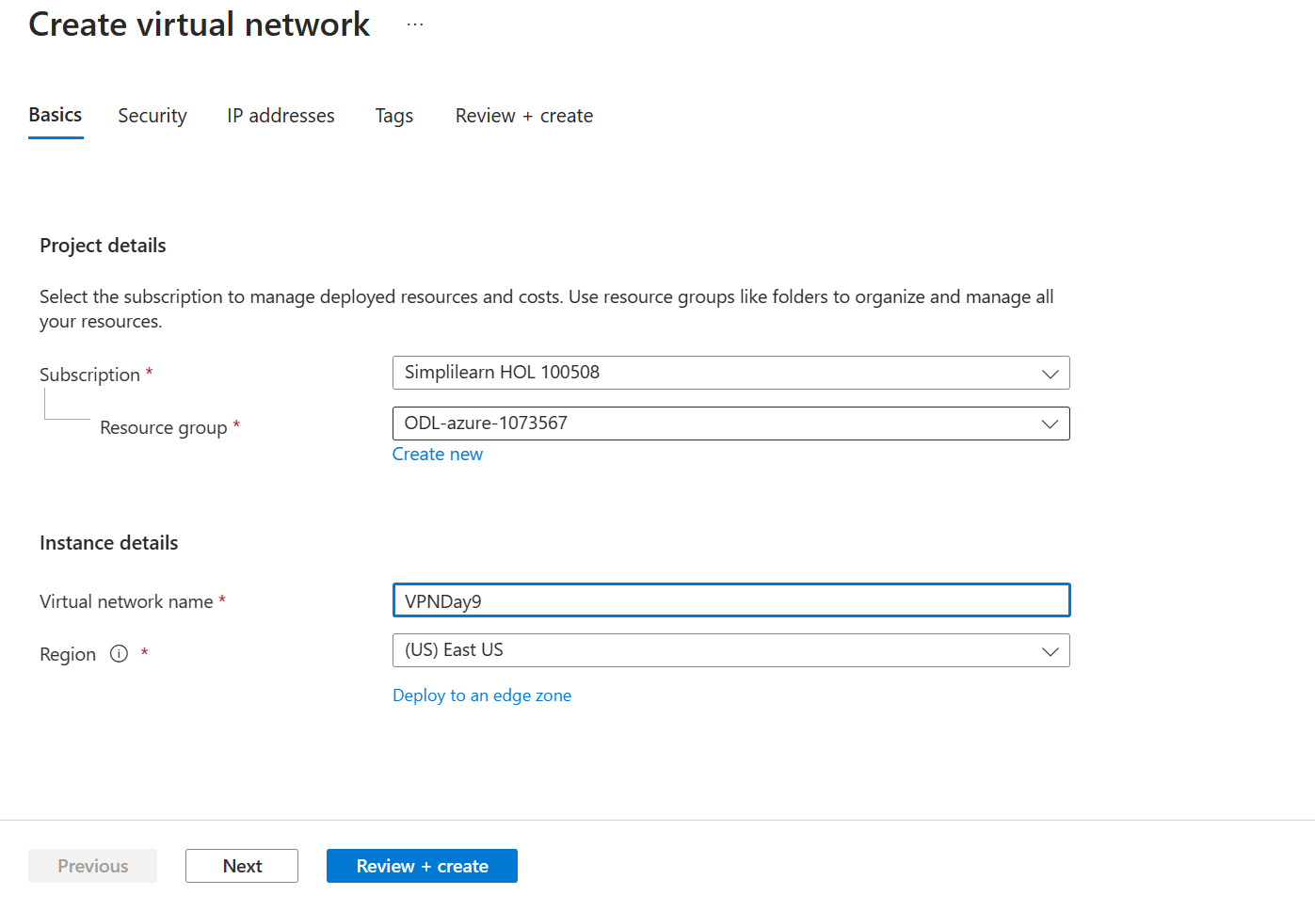

Click on create and review

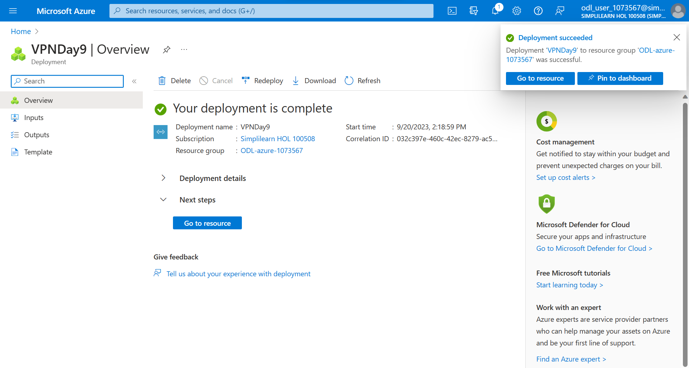

Step 3: Go to dashboard-> create resources->sql Database

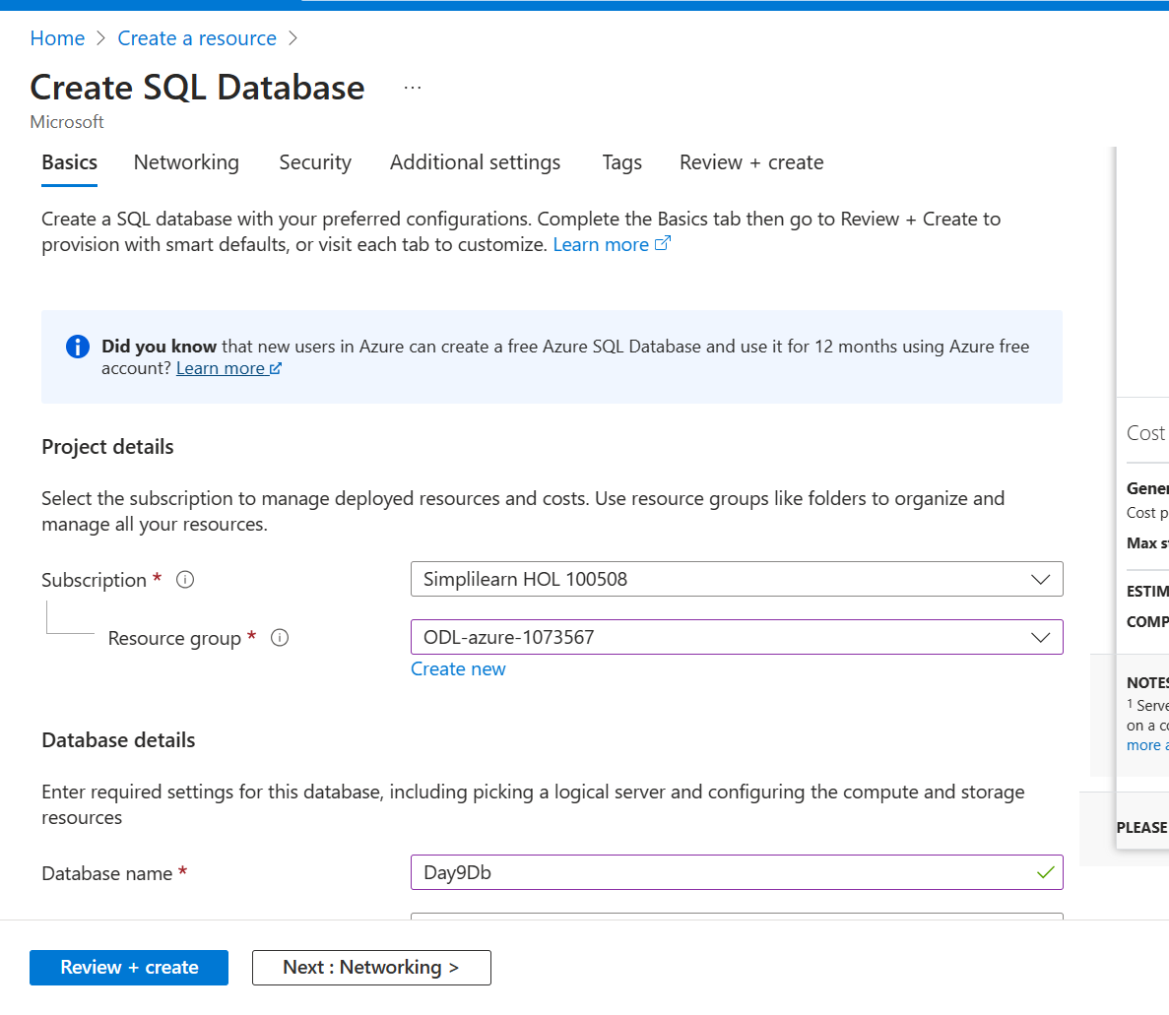

Click on Add Server

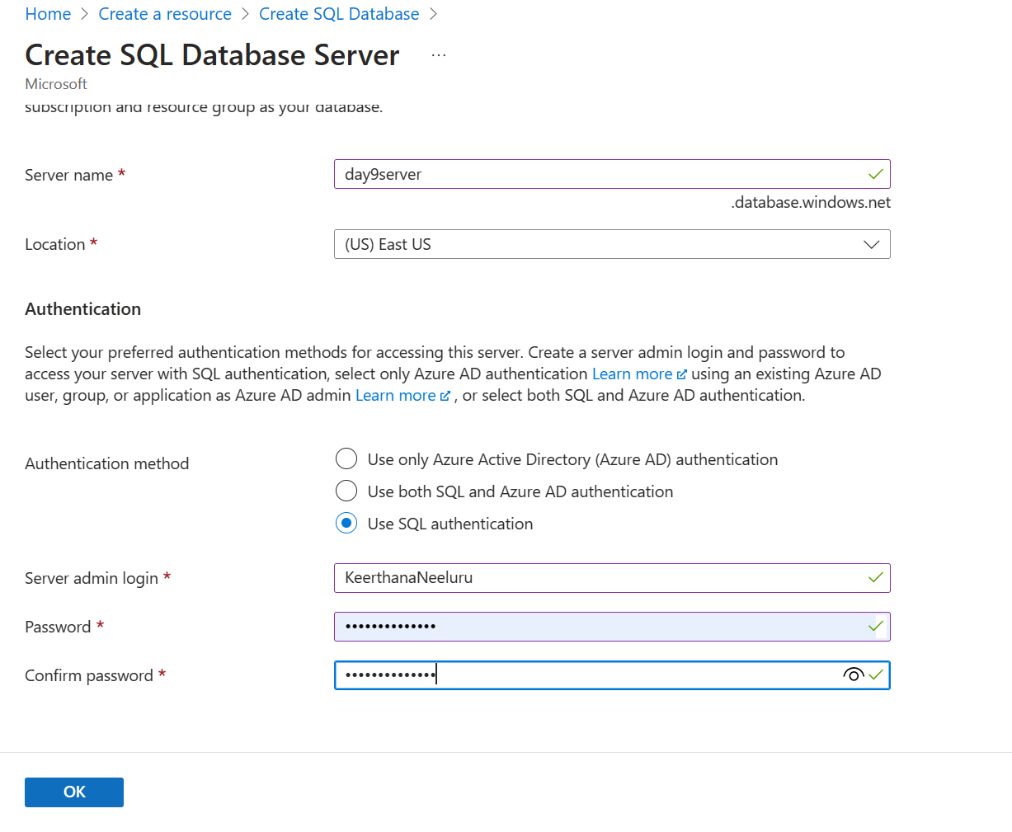

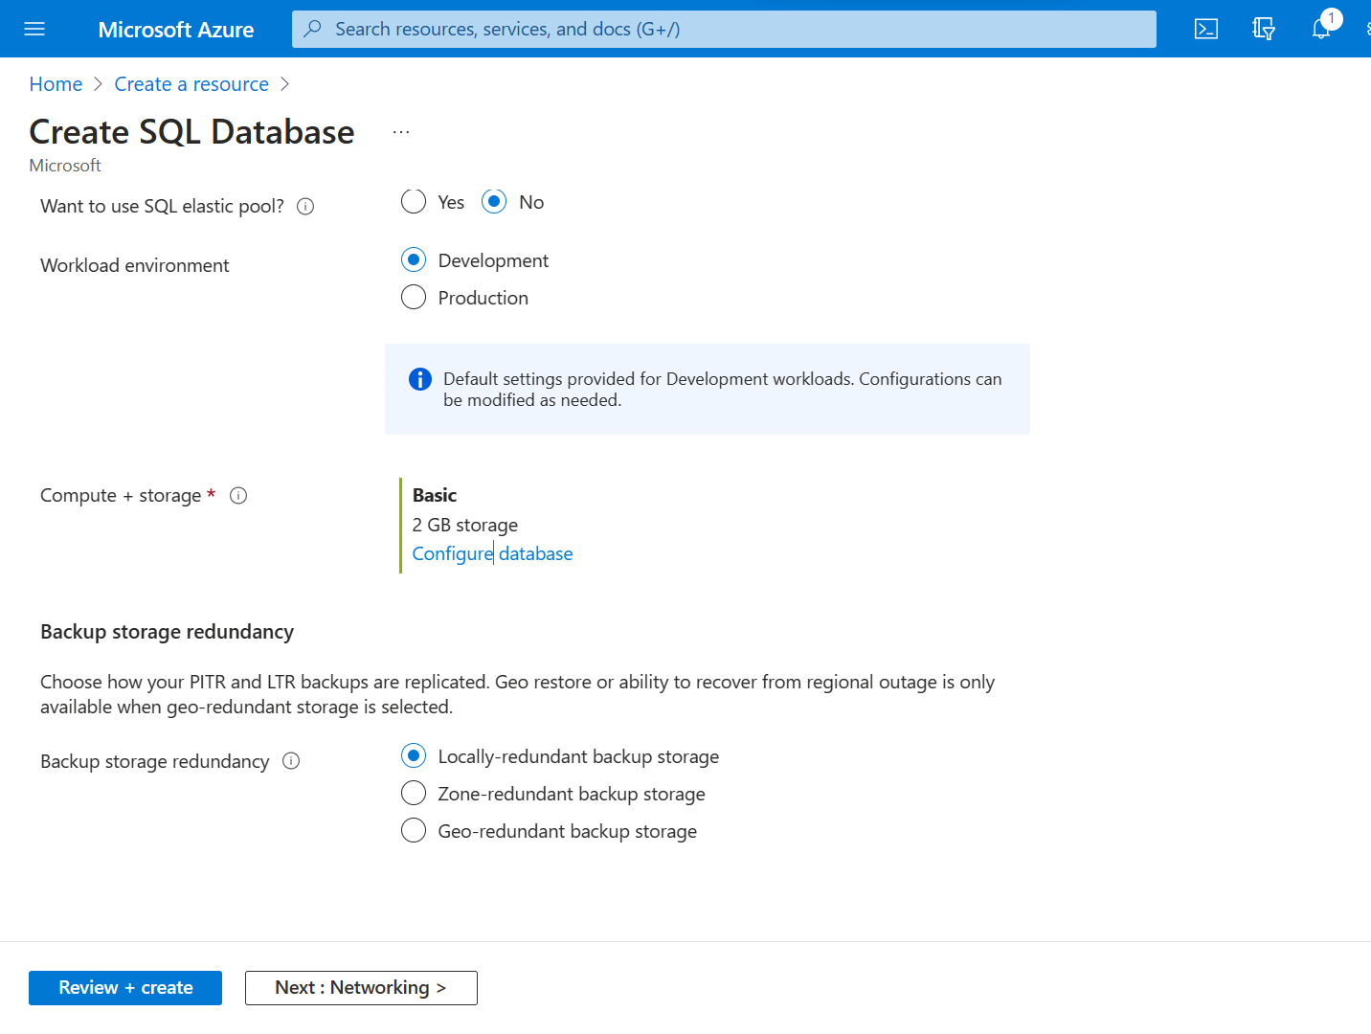

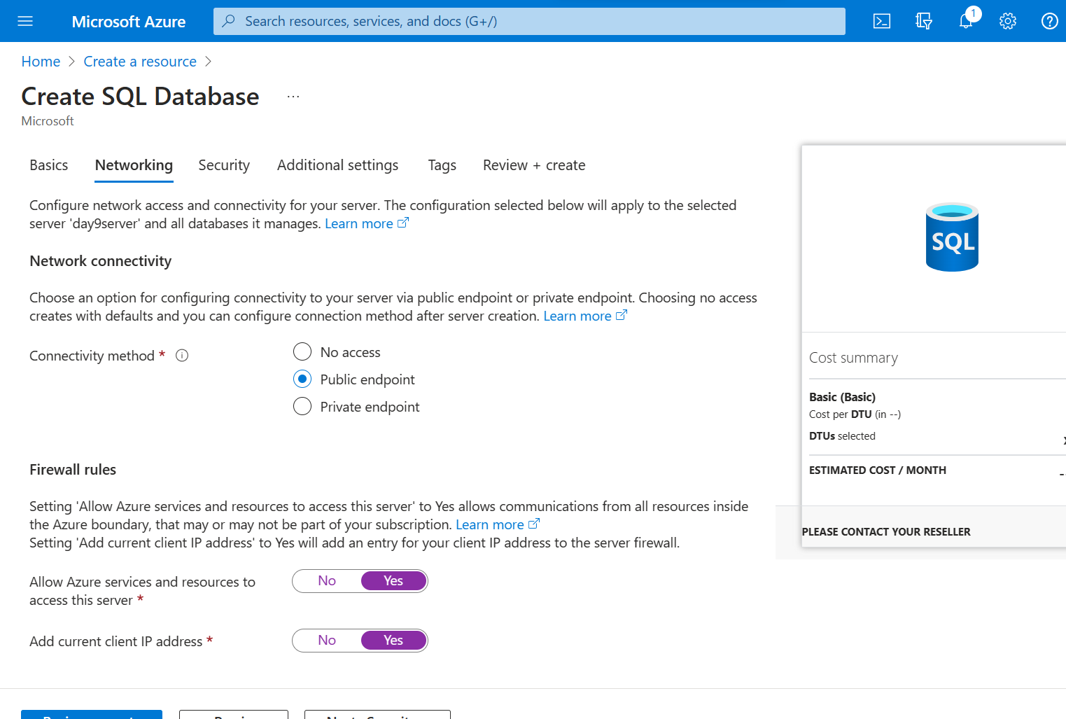

Click on review+create

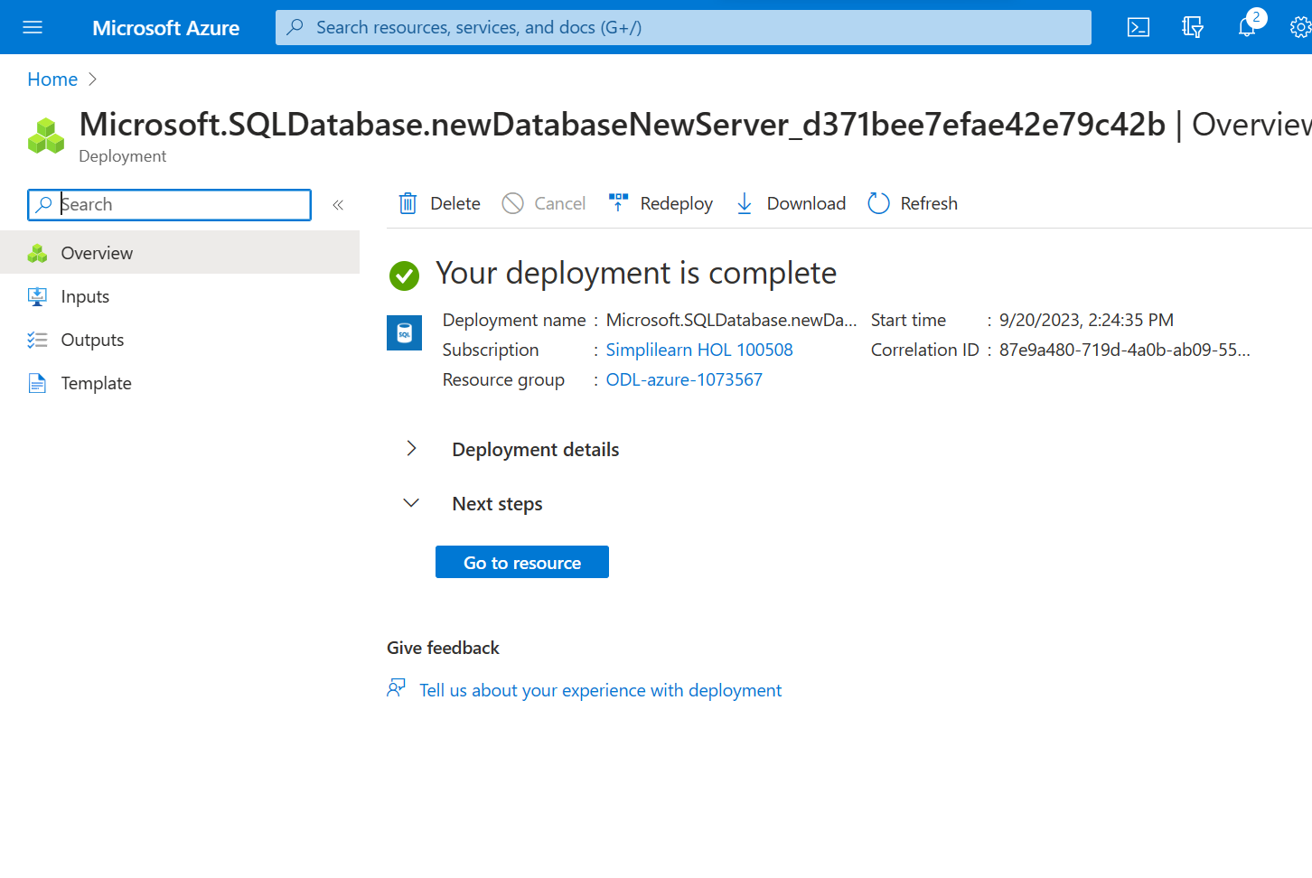

Step 4 :

Click on go to resources->select query Editor(Preview)->Create few tables and populate them with random data

create table Author

(

Id int primary key,

AuthName nvarchar(50) not null

)

create table Publisher

(

PId int primary key,

PName nvarchar(50) not null,

Address nvarchar(50)

)

create table BookCategory

(

CatId int primary key,

Genre nvarchar(50) not null

)

create table Book

(

BookId int primary key,

BookName nvarchar(50),

BookPrice int,

BookCat int foreign key references BookCategory ,

BookPublish int foreign key references Publisher

)

create table BookAuthor

(

BAId int primary key,

BId int foreign key references Book,

AId int foreign key references Author

)

INSERT INTO Author (Id, AuthName)

VALUES

(1, 'Author 1'),

(2, 'Author 2'),

(3, 'Author 3'),

(4, 'Author 4'),

(5, 'Author 5')

INSERT INTO Publisher (PId, PName, Address)

VALUES

(1, 'Publisher 1', 'Address 1'),

(2, 'Publisher 2', 'Address 2'),

(3, 'Publisher 3', 'Address 3'),

(4, 'Publisher 4', 'Address 4'),

(5, 'Publisher 5', 'Address 5')

INSERT INTO BookCategory (CatId, Genre)

VALUES

(1, 'Genre 1'),

(2, 'Genre 2'),

(3, 'Genre 3'),

(4, 'Genre 4'),

(5, 'Genre 5')

INSERT INTO Book (BookId, BookName, BookPrice, BookCat, BookPublish)

VALUES

(1, 'Book 1', 10, 1, 1),

(2, 'Book 2', 15, 2, 2),

(3, 'Book 3', 20, 3, 3),

(4, 'Book 4', 25, 4, 4),

(5, 'Book 5', 30, 5, 5)

INSERT INTO BookAuthor (BAId, BId, AId)

VALUES

(1, 1, 1),

(2, 2, 2),

(3, 3, 3),

(4, 4, 4),

(5, 5, 5);

select\* from Author

select \* from Publisher

select \* from BookCategory

select \* from Book

select \* from BookAuthor

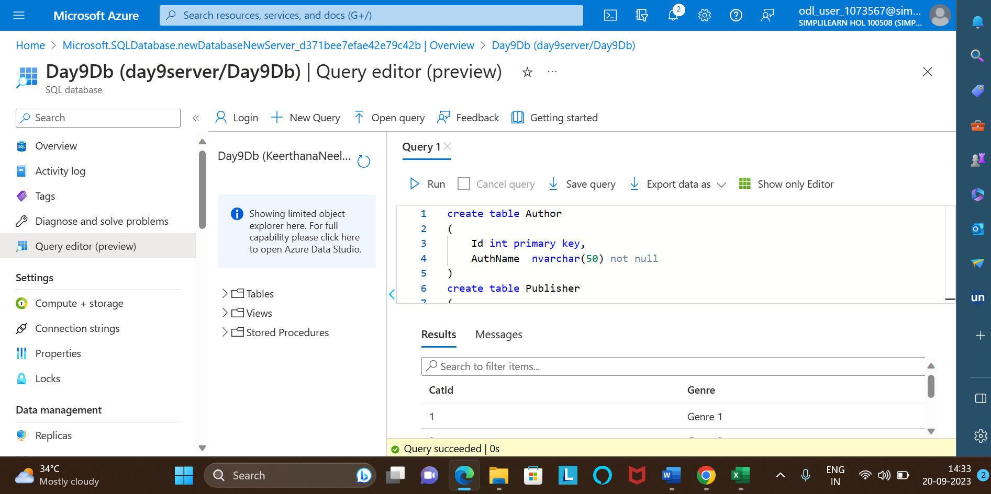

Step 5: check the tables in sql server

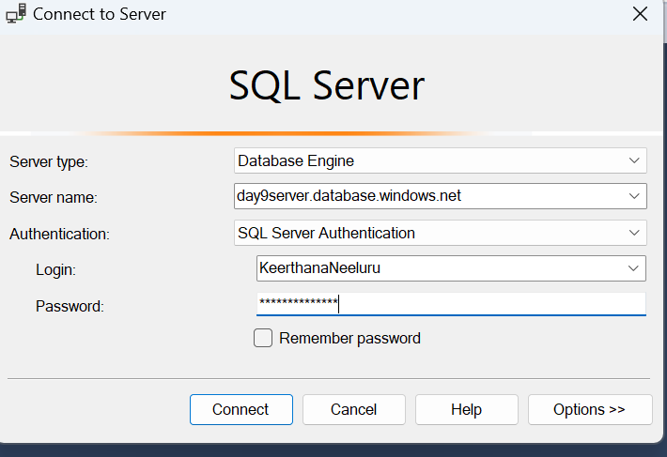

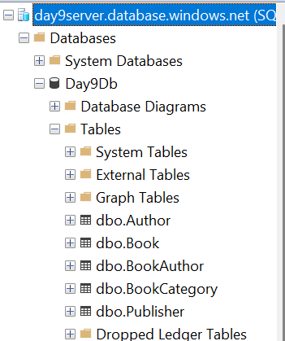

Step 6:

Go to dashboard in microsoftazure-> create resources-> virtual machine

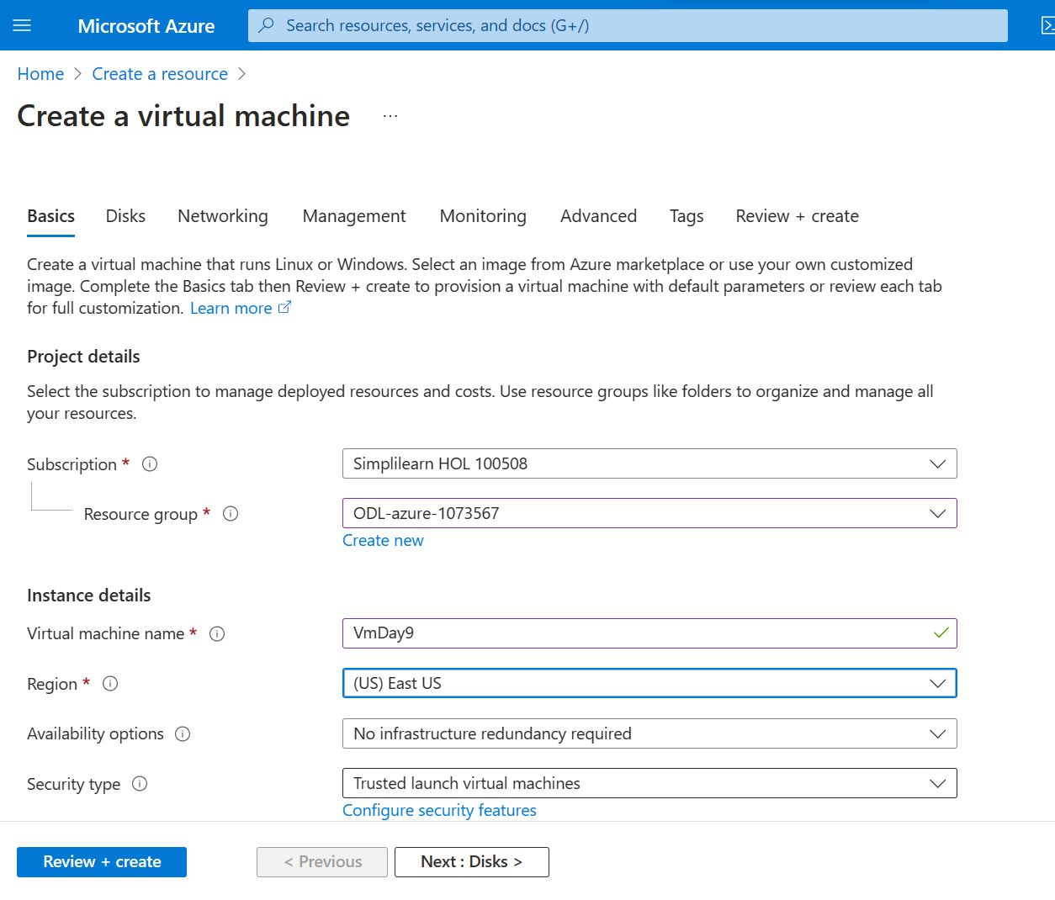

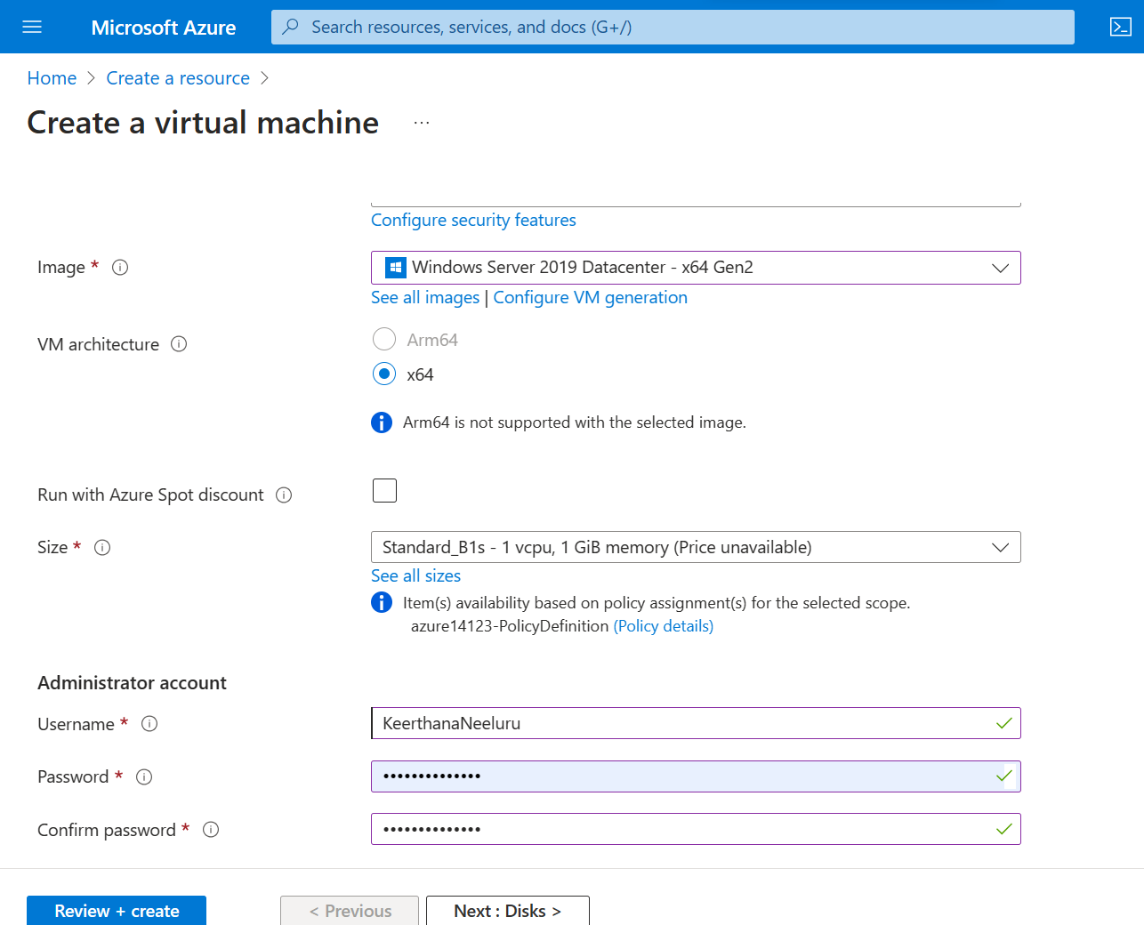

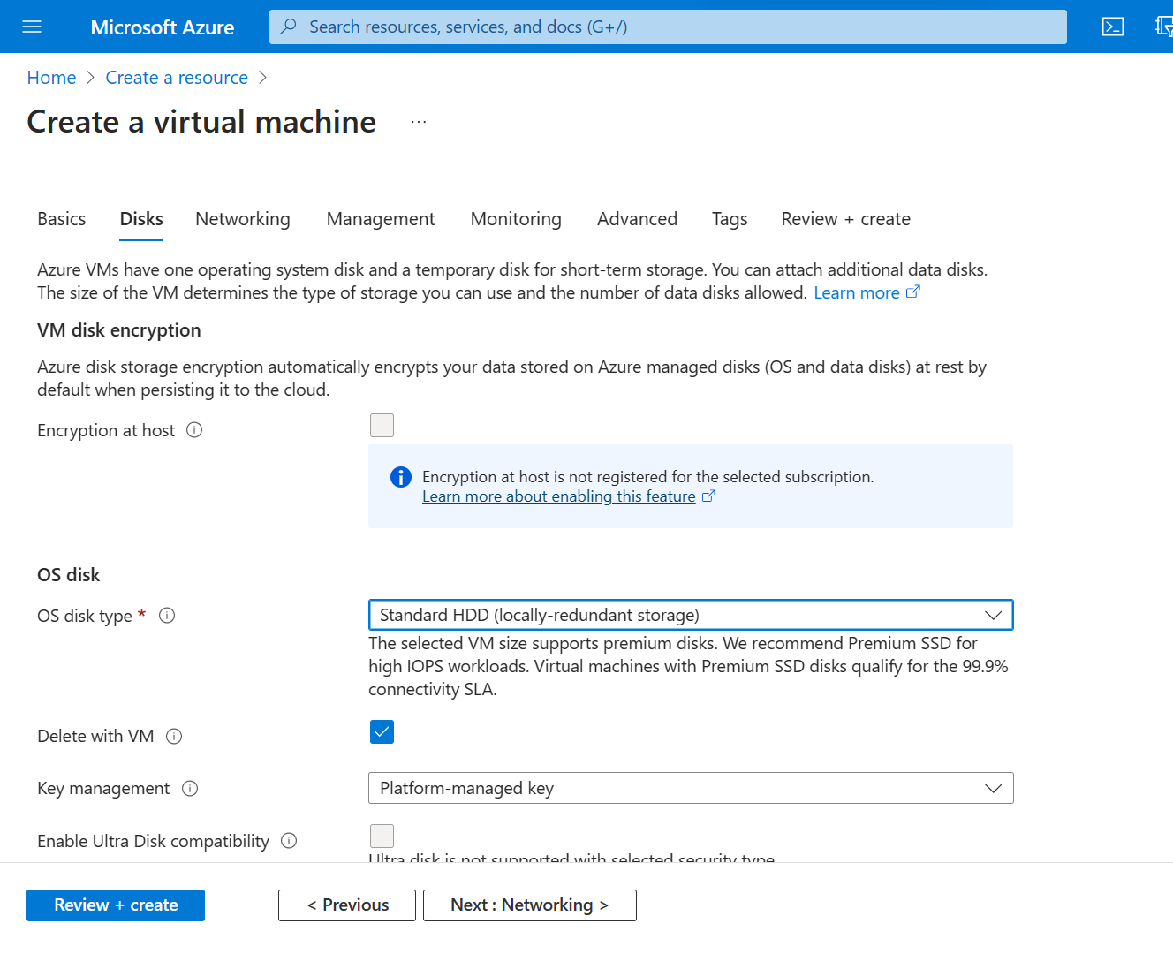

Click on review+create

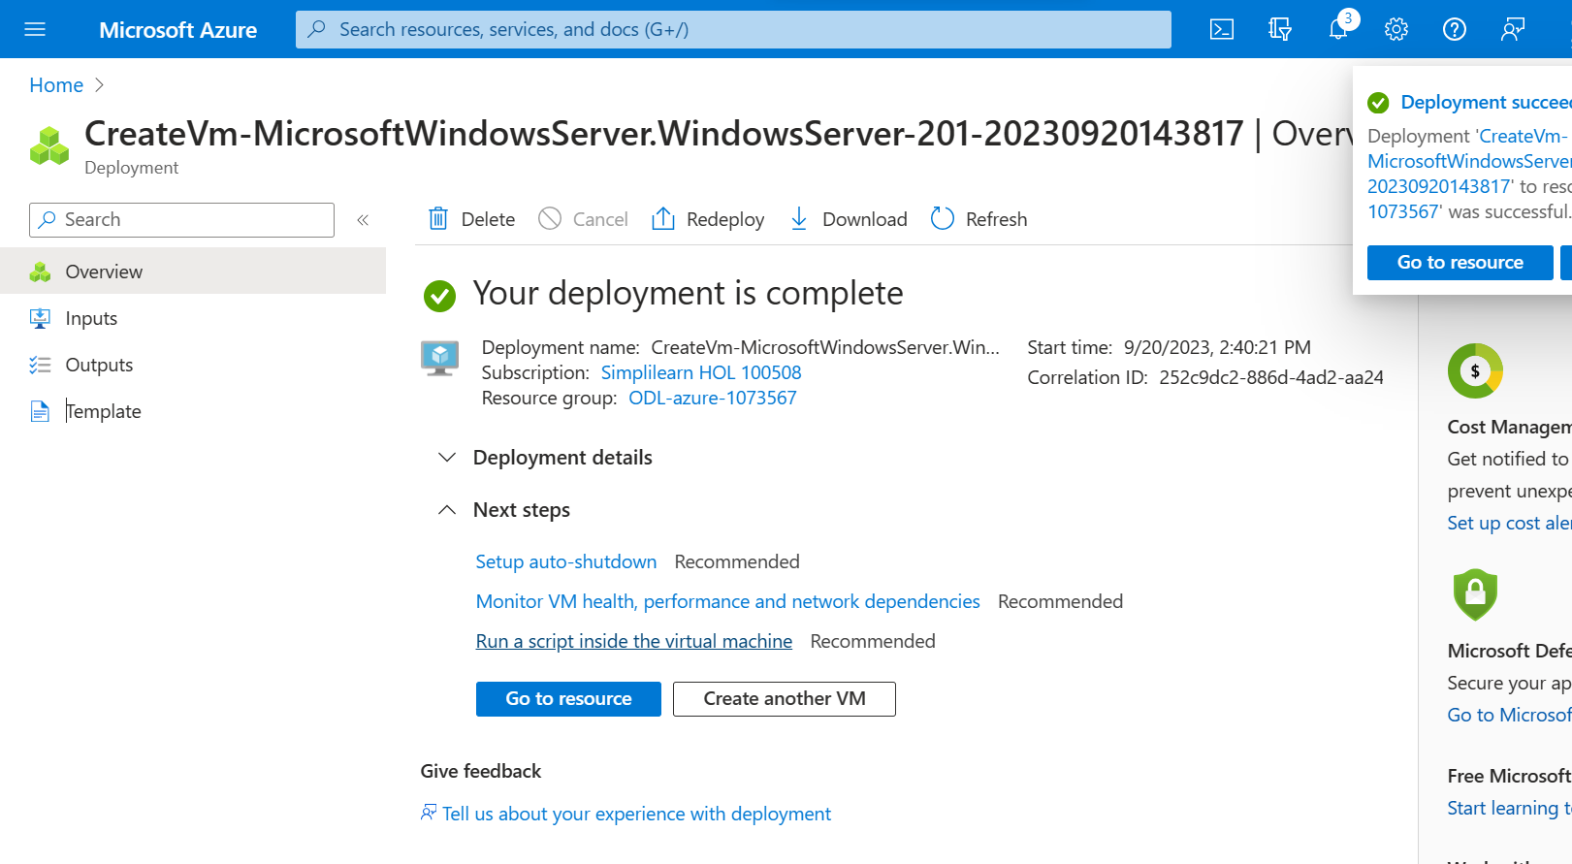

Click on go to resource

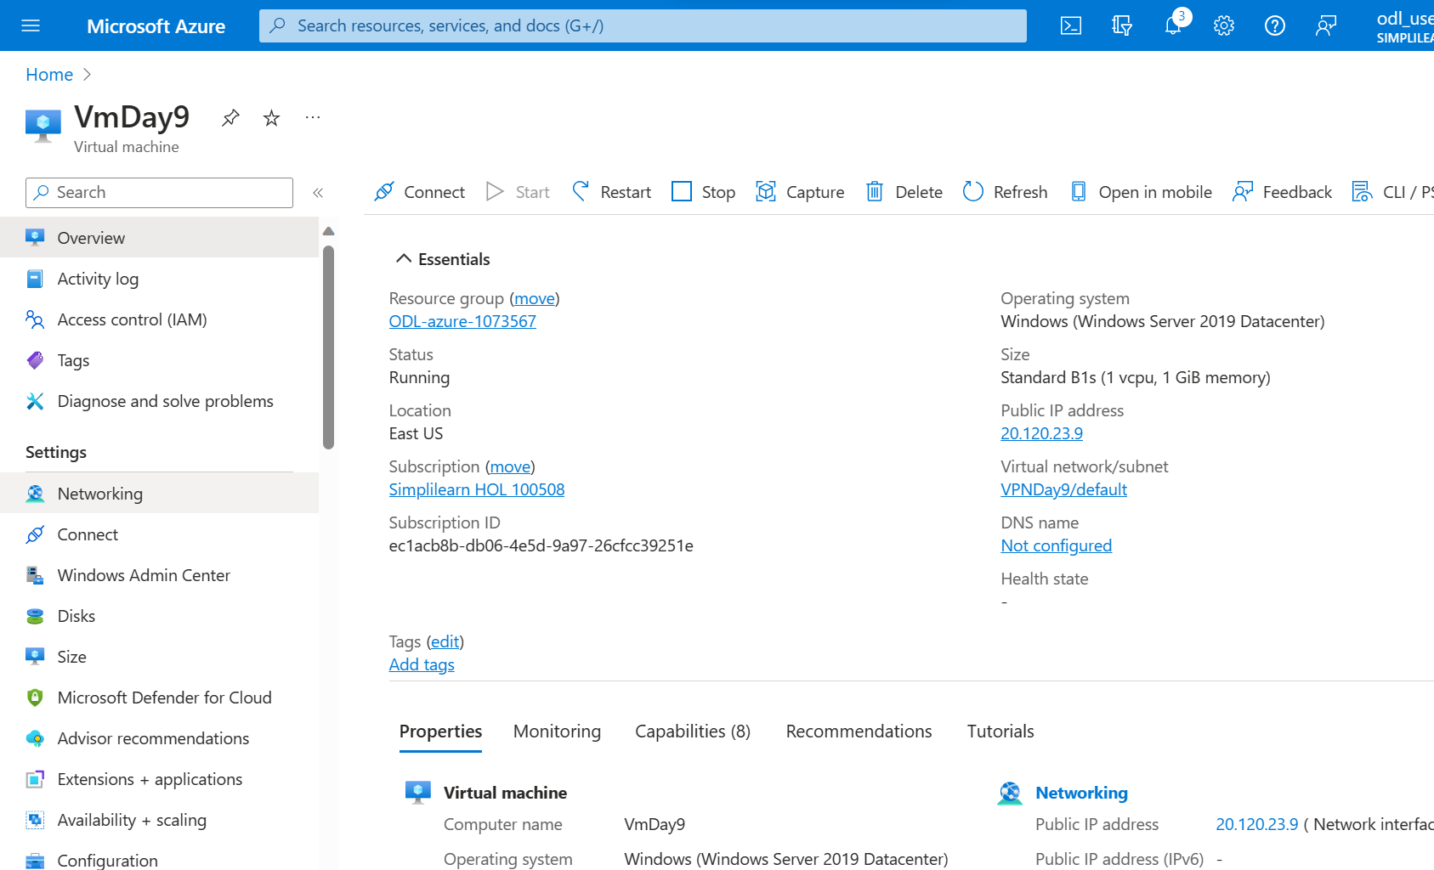

Click on connect

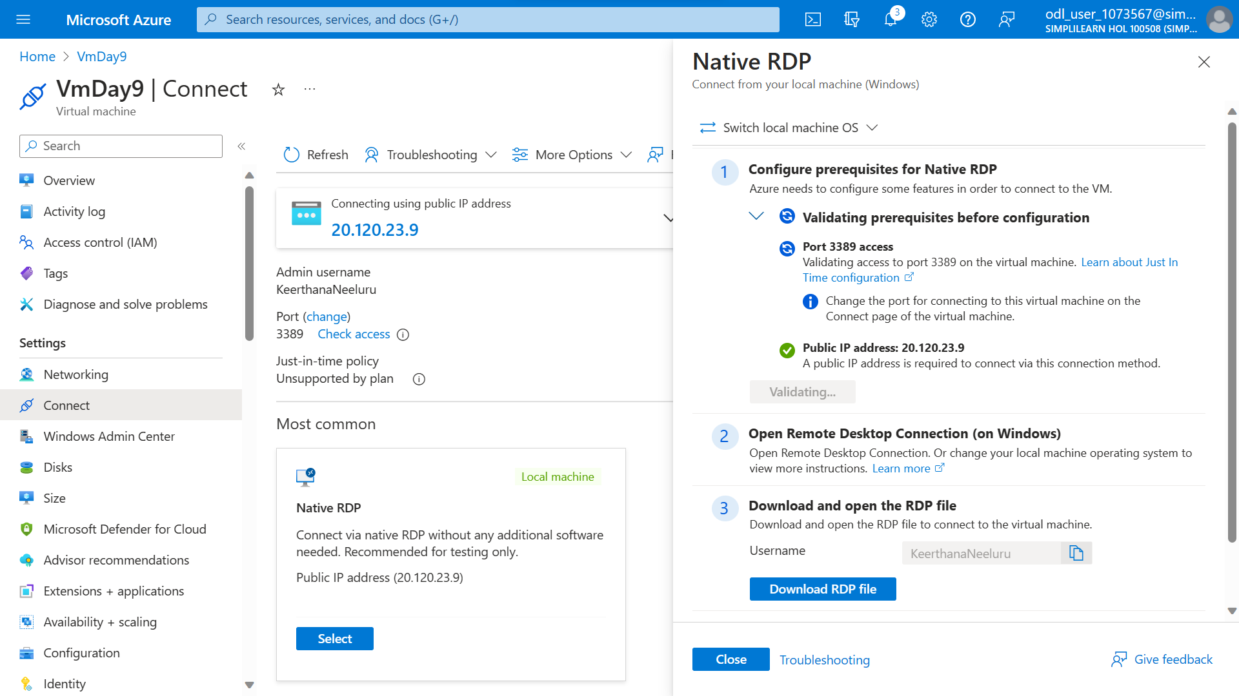

Select Native RDP and Download RDP file and connect to virtual machine